Session 4: CUSTOMIZATION – I, BUILD IMAGE WITH PROVIONING PACKAGE

# CREATING PROVISIONING PACKAGE AND ADDING IT TO THE IMAGE

**PURPOSE: Understand how to create provisioning package to configure your setting and make an image with it**

Reference –  [Create Provisioning Image](https://github.com/MicrosoftDocs/windows-iotcore-docs/blob/fabricam/windows-iotcore/manufacturing-guide/Customize-Image/CreateProvisioningPackage.md)

* From your Technician PC, run **Windows Imaging and Configuration Designer**.
* Create a new project by clicking **File > New Project**.
* Select **Provisioning Package** and click Next.
* On the Choose which settings to view and configure page, select **Windows 10 IoT Core**. Click Next

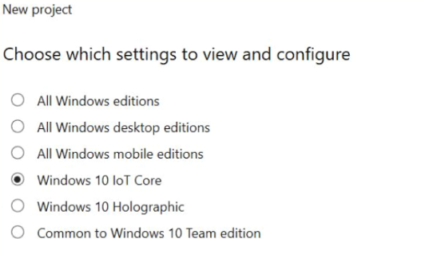

* At the **Import a provisioning package**(optional) page, leave the entry blank and click **Finish**.
* Add a sample setting. For our example, we will specify a default startup app that executes when the IoT Core device is booted up. Let’s use **IOTBrowser** app or your **Sample** app
  + Change the View dropdown under Available Customizations to Common IoT Settings.
  + Expand the **Runtime settings > Startup App > Default** node.
  + Enter the **Application User Model ID (AUMID)** of the app you want to be the default startup app.

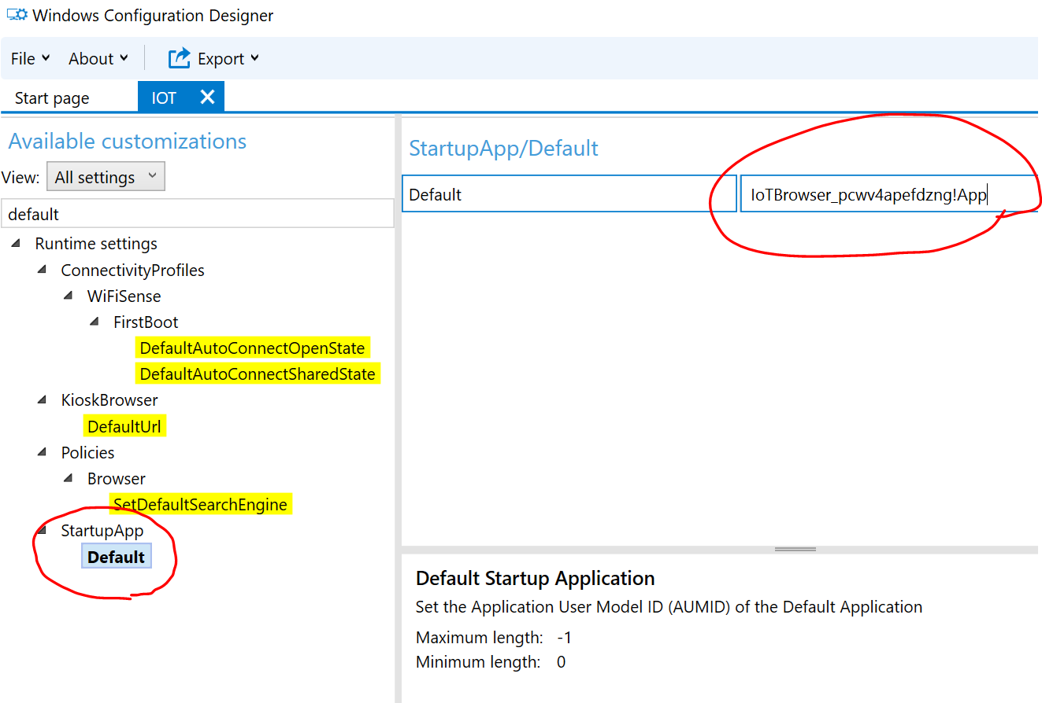

**[Note]** If you choose **IoTBrowser** then **you should add the app package to the image** refer previous sessions

**[Note]** How to get **AUMID** for your target app? Refer this [link](https://docs.microsoft.com/en-us/windows/configuration/find-the-application-user-model-id-of-an-installed-app) . Run following in powershell on installed

|  |
| --- |
| *$installedapps = get-AppxPackage*  *$aumidList = @()*  *foreach ($app in $installedapps)*  *{*  *foreach ($id in (Get-AppxPackageManifest $app).package.applications.application.id)*  *{*  *$aumidList += $app.packagefamilyname + "!" + $id*  *}1*  *}*  *$aumidList* |

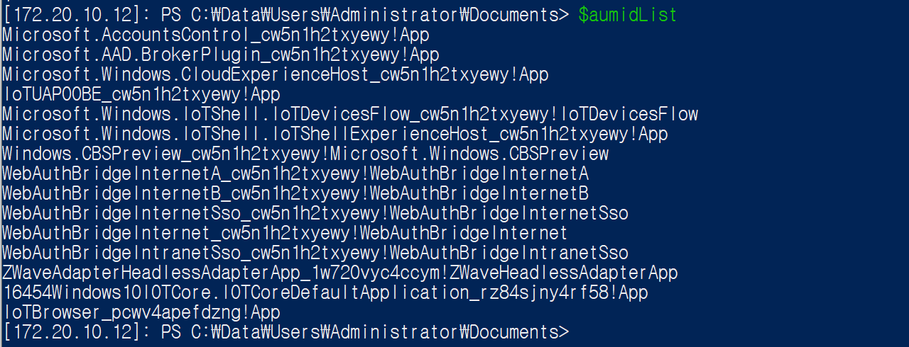

*Ex) AUMID = IoTBrowser_pcwv4apefdzng!App*

**[Tip]**If you want to build Microsoft IoTBrowser Sample app then if might need to change package publisher setting, certificate from MSFT to your own. Otherwise, you might get following error when you add package

*“Error: Using MSFT cert is blocked as this will cause provisioning failure. Use different certificate”*

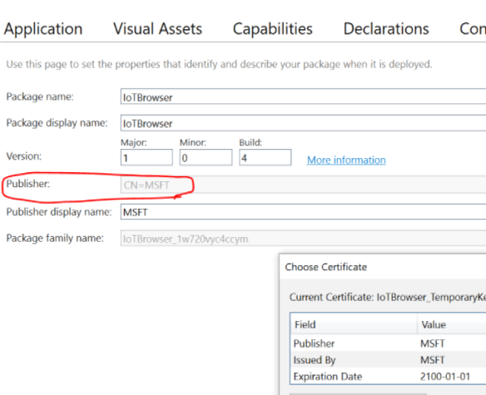

<Publisher is MSFT>

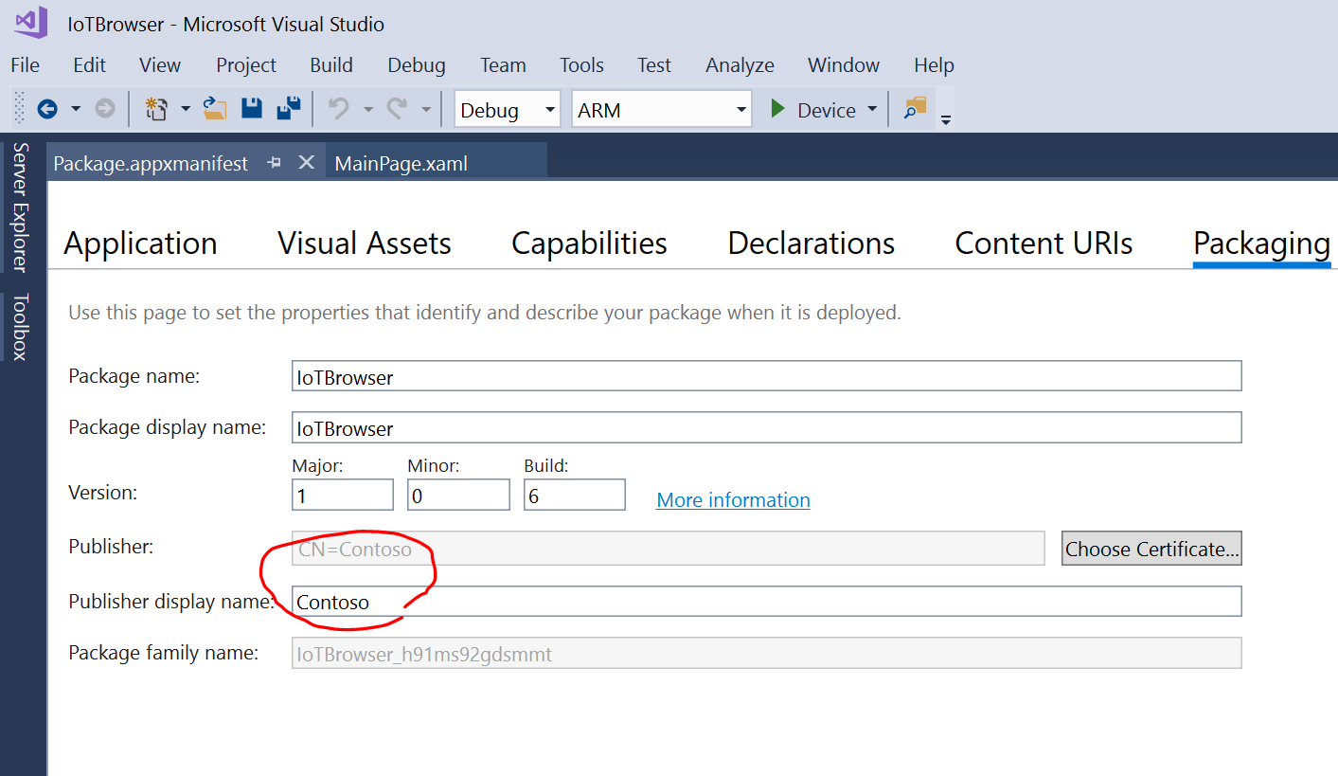

<Publisher is Contoso>

* Save the project.
* Export the provisioning package.
* Click **Export > Provisioning Package**. An export dialog will appear. You can modify the Name, Version and Rank field, as well as the Owner. Select OEM for Owner and click Next.

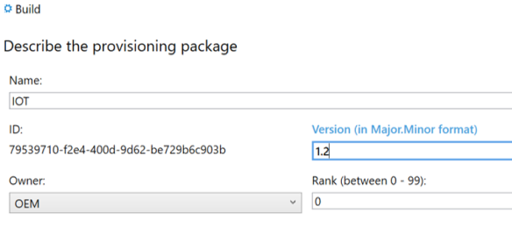

* Under Select security details for the provisioning package, **uncheck** the **Encrypt package** and **Sign package** checkboxes. Click Next.

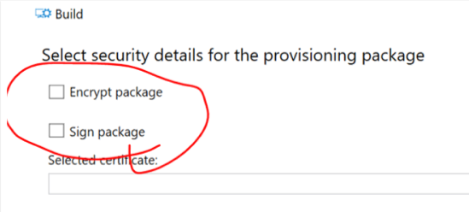

* Click **Build** to build the provisioning package. A dialog listing the output location will appear when the export is complete. Click **Finish**.
* **Keep the path** to the folder keeping generated provisioning package.
* Create a provisioning package using [Add-IoTProvisioningPackage](https://github.com/ms-iot/iot-adk-addonkit/blob/master/Tools/IoTCoreImaging/Docs/Add-IoTProvisioningPackage.md):

*Ex) Add-IoTProvisioningPackage Prov.IoTProvisioning01 "C:\Users\kijokim\Documents\Windows Imaging and Configuration Designer (WICD)\IOT\IOT.ppkg"*



* Create provisioning cab package or rebuild New-IoTCabPackage All

*Ex) New-IoTCabPackage PROV.IotProvisioning01*

*Ex) New-IoTCabPackage All*

* Update the product test configuration file using [Add-IoTProductFeature](https://github.com/ms-iot/iot-adk-addonkit/blob/master/Tools/IoTCoreImaging/Docs/Add-IoTProductFeature.md)::

*Ex) Add-IoTProductFeature ProductA Test PROV_IOTPROVISIONING01 -OEM*

* Build the FFU image again, as specified in Creating a Basic IoT Core Image. You should only have to run the New-IoTFFUImage command:

*Ex) New-IoTFFUImage ProductA Test*

* Flash FFU image
* Verify the default setting was done, default app is changed.

# quiz

**Q1 : Create provisioning package to connect your device to your AP through WIFI.**

**Q2:** **Create provisioning package to disable auto update and make the image with it.**